PROJECT TITLE : **GARAGE MANAGEMENT**

**SYSTEM**

**College name** : Kathir college of Arts and Science

**college code** : BRUAH

**Team ID** : NM2025TMID24414

**Team Members :**

Team Leader : Anusheela.S

Email:dhanushiyaanushila@gmail.com

Team Member1 : Janani.A

Email:janania327@gmail.com

Team Member2 : Subashree.P

Email:psuba4031@gmail.com

Team Member3 : Malarvilzhi.R

Email:malaram11045@gmail.com

**1.INTRODUCTION**

# 1.1 Project Overview

The Garage Management System is a valuable tool for automotive repair facilities, helping them deliver top-notch service, increase operational efficiency, and build lasting customer relationships. With its user-friendly interface and powerful features, GMS empowers garages to thrive in a competitive market while ensuring a seamless and satisfying experience for both customers and staff.

# 1.2 Purpose

The purpose of developing the Garage Management System is to provide a one-stop digital solution that streamlines all the essential operations of a garage. The system is designed to reduce manual workload by capturing customer and vehicle details in a centralized database, automating service bookings, and ensuring accurate invoice generation.

Another major objective is to assign responsibilities to employees in a structured manner and provide managers with better visibility into the status of services. By automating notifications such as booking confirmations, service completion alerts, and payment reminders, the system enhances communication between the garage and its customers. Ultimately, this leads to faster turnaround time, reduced chances of human error, and a much more professional customer experience.

The GMS is not only beneficial for customers but also for garage employees and managers, as it provides them with an organized, transparent, and efficient way of working.

**Creating Developer Account in Salesforce:**

By using the link  [**https://developer.salesforce.com/signup**](https://developer.salesforce.com/signup) we can create our accout in salesforce. We need to fill the required information ,then we get the email for verification. So now we got into our Salesforce Home page .

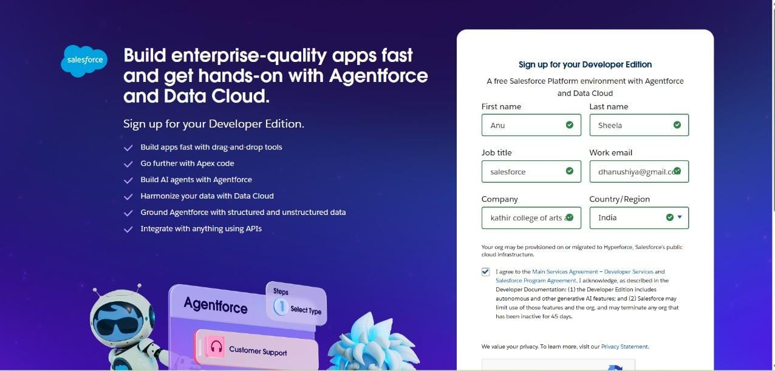

**Create Customer Details Object:**

From Home page , go to setup page then click on Object manager , then create a custom object with the label name as Customer Details and enter the record name as given in guidance.

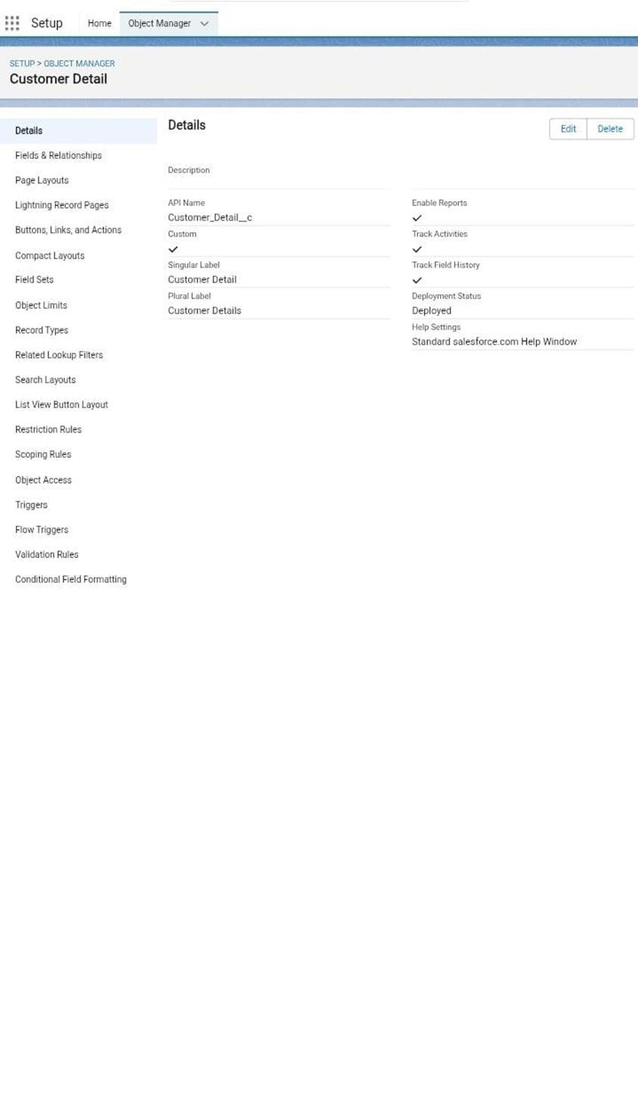

By the same action we gonna create the Appointment Object , Service Records Object and then Billing Details and feedback Object.

**Creating Appointment Object:**

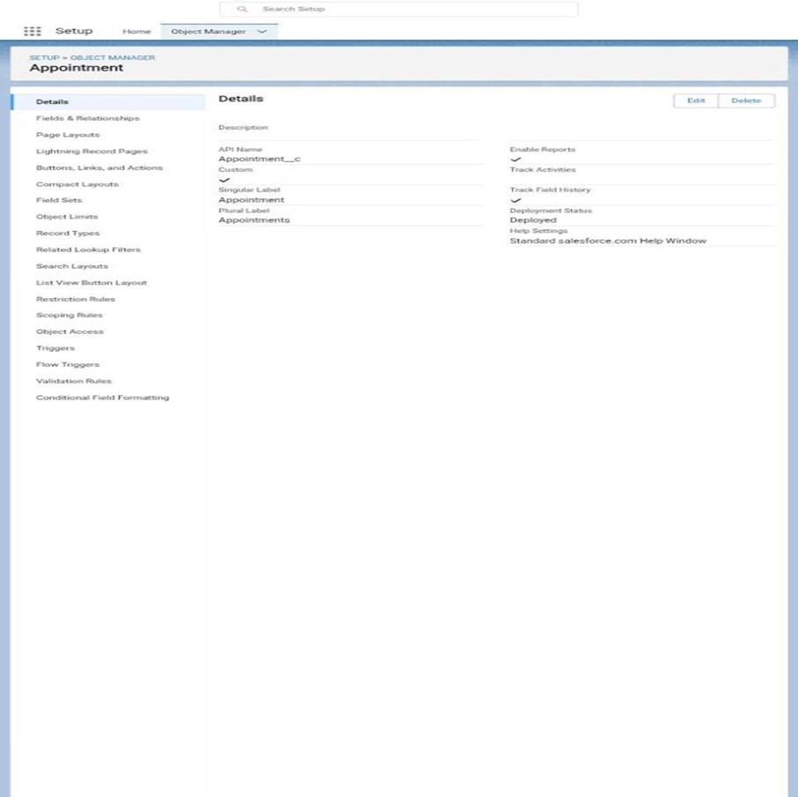

**Create Service Records Object:**

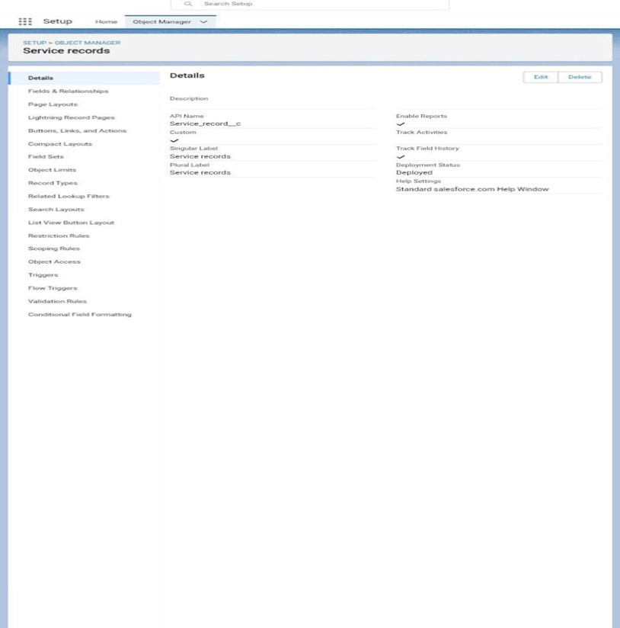

**Create Billing Details and Feedback Object:**

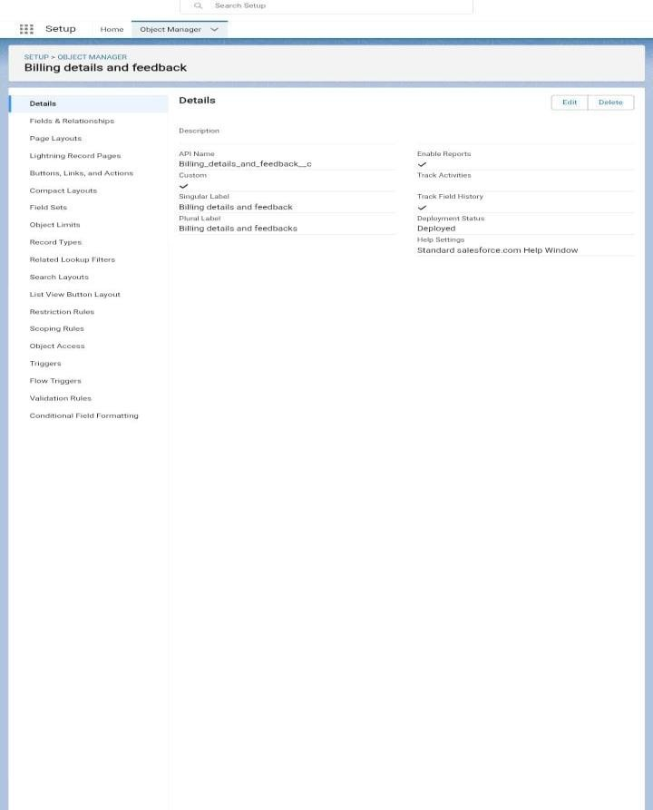

**Tabs:**

A tab is like user interface that is used to build records for objects and to view the records in the object. Creating a Customer Details Tab:

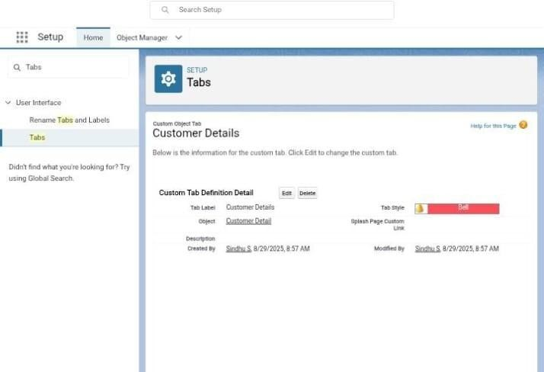

**Creating Appointment Tab:**

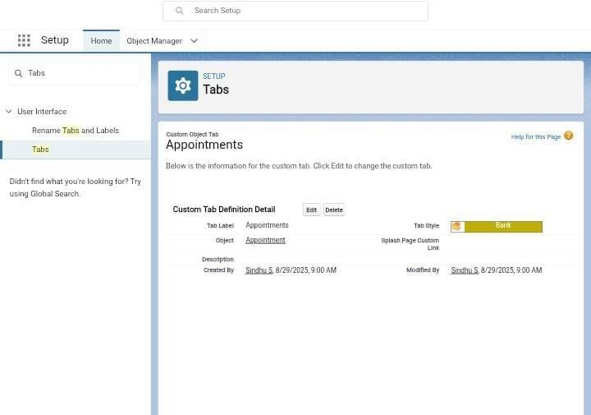

**Create Service Record Tab:**

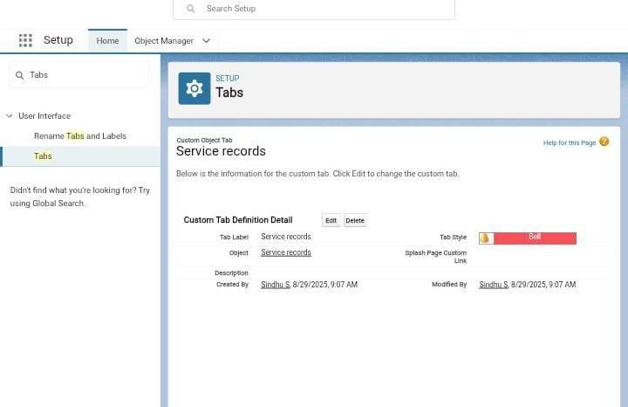

**Create Billing Details and Feedback object:**

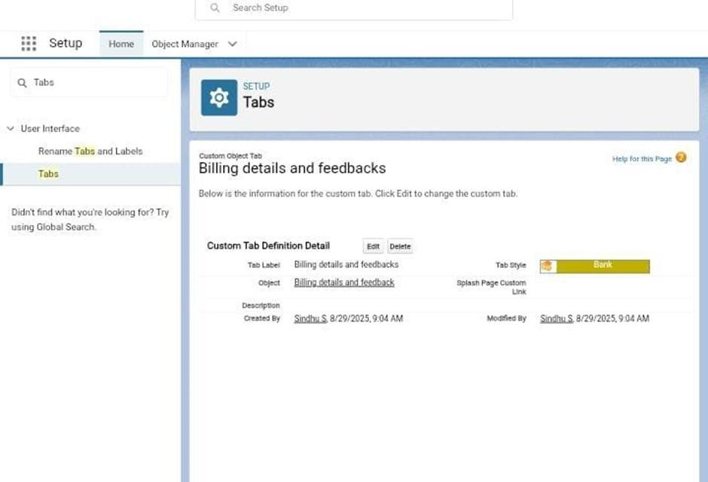

**The Lightning App:**

An app is a collection of items that work together to serve a particular function.

**Create A Lightning App:**

To create a lightning app , go to setup page search app manager ,click new lightning app. Fill the app name as Garage Management System , keep the utility items as default. Then do the requirements as per the guidance.

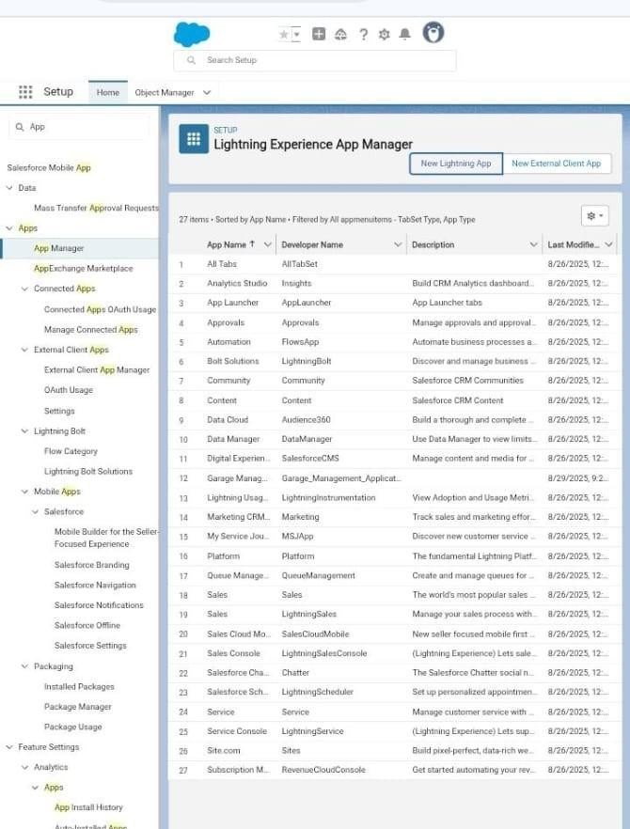

**Fields:**

When we talk about Salesforce, Fields represent the data stored in the columns of a relational database. It can also hold any valuable information that you require for a specific object. Hence, the overall searching, deletion, and editing of the records become simpler and quicker.

**Creation of Fields For The Customer Details Object:**

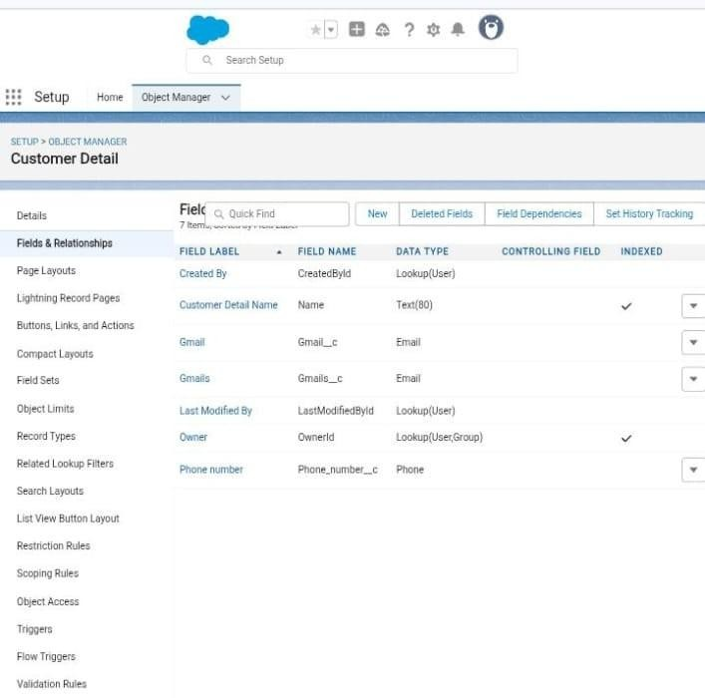

**Creation of Look up Fields For The Appointment Object:**

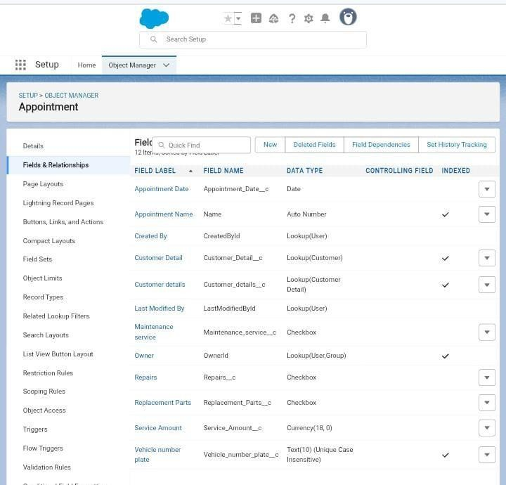

**Creation of Lookup Fields For The Service Records Object:**

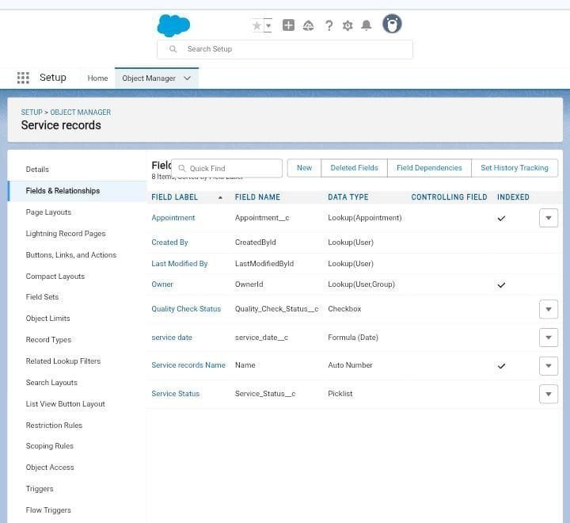

**Creation of Lookup Fields For The Billing and Feedback Object:**

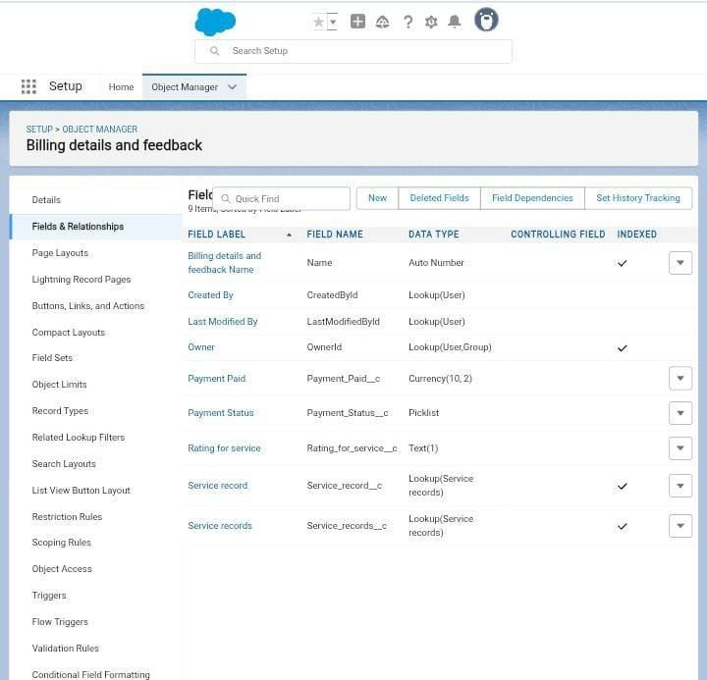

**Creation of Checkbox Fields on Appointment Object:**

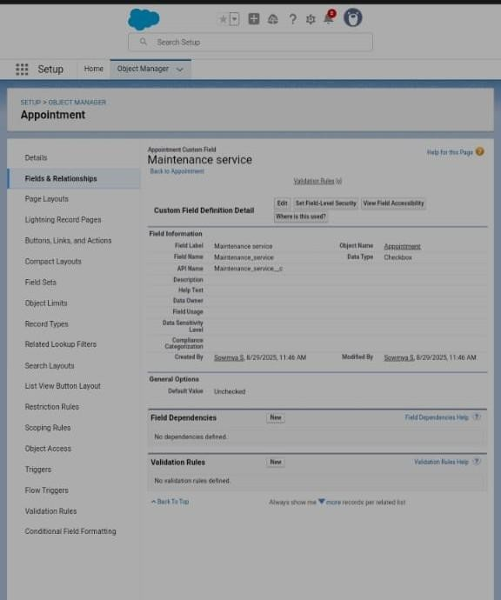

**Creation of Another Checkbox Fields on Appointment Object:**

Go to setup page click on Object manager , search for appointment. In

Appointments click Fields and Relationship, then click new. Select the data type as “check box”. Enter the field label as Repairs , field name will be auto populated ,set the default value as unchecked then click save. Again follow the same step to create another checkbox with given field name.

**Creation of Checkbox Field on Service Records Object:**

Go to setup page click on Object manager , search for Service Record. In Service Record click Fields and Relationship, then click new. Select the data type as “check box”. Enter the field label as Quality Check, field name will be auto populated ,set the default value as unchecked then click save.

**Creation of Date Field on Appointment Object:**

Go to setup page click on Object manager , search for appointment. In appointment click Fields and Relationship, then click new. Select the data type as “Date”. Enter the field label as Appointment Date, field name will be auto populated , make it as required field by clicking the required option, click save.

**Creation of Currency Field on Appointment Object:**

Go to setup page click on Object manager , search for appointment. In appointment click Fields and Relationship, then click new. Select the data type as “Currency”. Enter the field label as Service amount , field name will be auto populated , click save. By the same procedure we creating the field for Billing details and feedback object with the given field label.

**Creation of other three fields:**

So as per the given information we are creating Text fields, Picklist fields for Appointment and Billing Details and feedback with the given field name and data type. And the Formula field in Service Record Object is also created with the require data type and the field label will be given by the instruction then save it.

**Validation Rule:**

Validation rules are applied when a user tries to save a record and are used to check if the data meets specified criteria. If the criteria are not met, the validation rule triggers an error message and prevents the user from saving the record until the issues are resolved.

**To create A Validation Rule to an Appointment Object:**

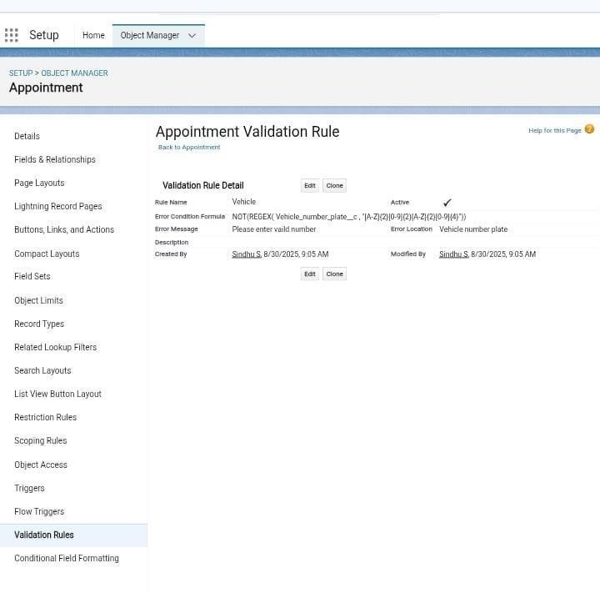

**To create A Validation Rule to an Billing Details and Feedback Object:**

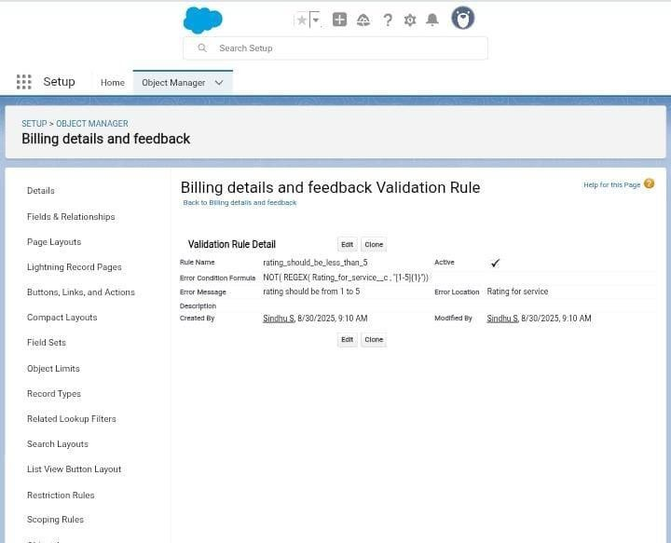

**Duplicate Rule:**

**To create a Matching Rule to an Customer Details Object:**

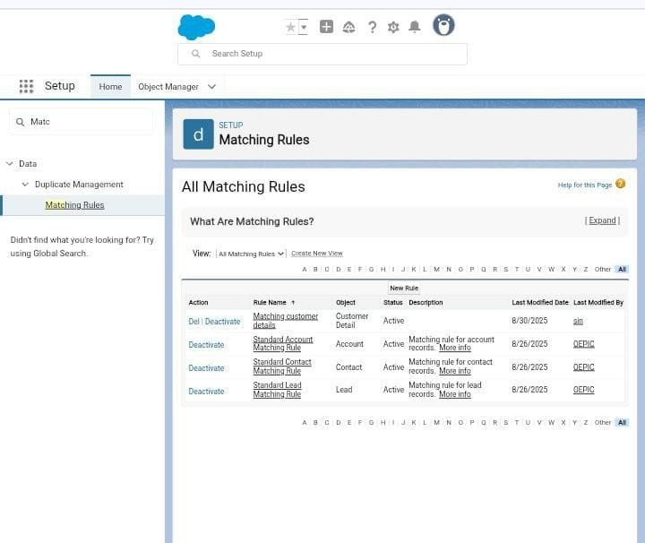

**To create a Duplicate Rule to an Customer Details Object:**

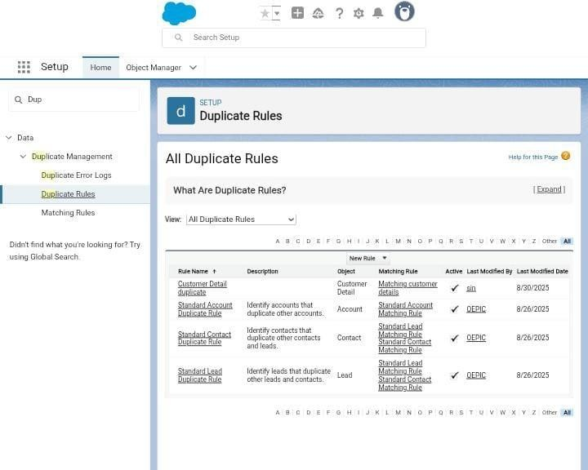

**Profiles:**

A profile is a group/collection of settings and permissions that define what a user can do in salesforce. Profile controls “Object permissions, Field permissions, User permissions, Tab settings, App settings, Apex class access, Visualforce page access, Page layouts, Record Types, Login hours & Login IP ranges. You can define profiles by the user's job function. For example System Administrator, Developer, Sales Representative.

**Manager Profiles:**

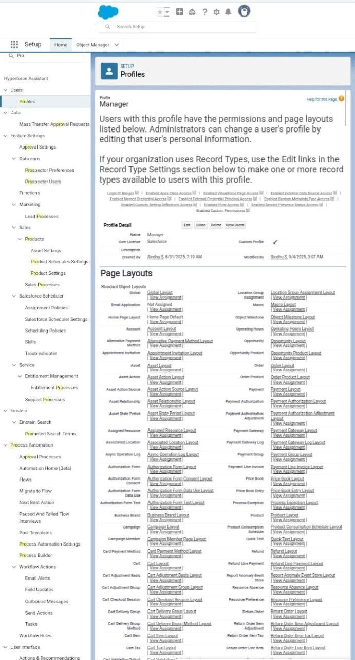

**Sales Person Profile:**

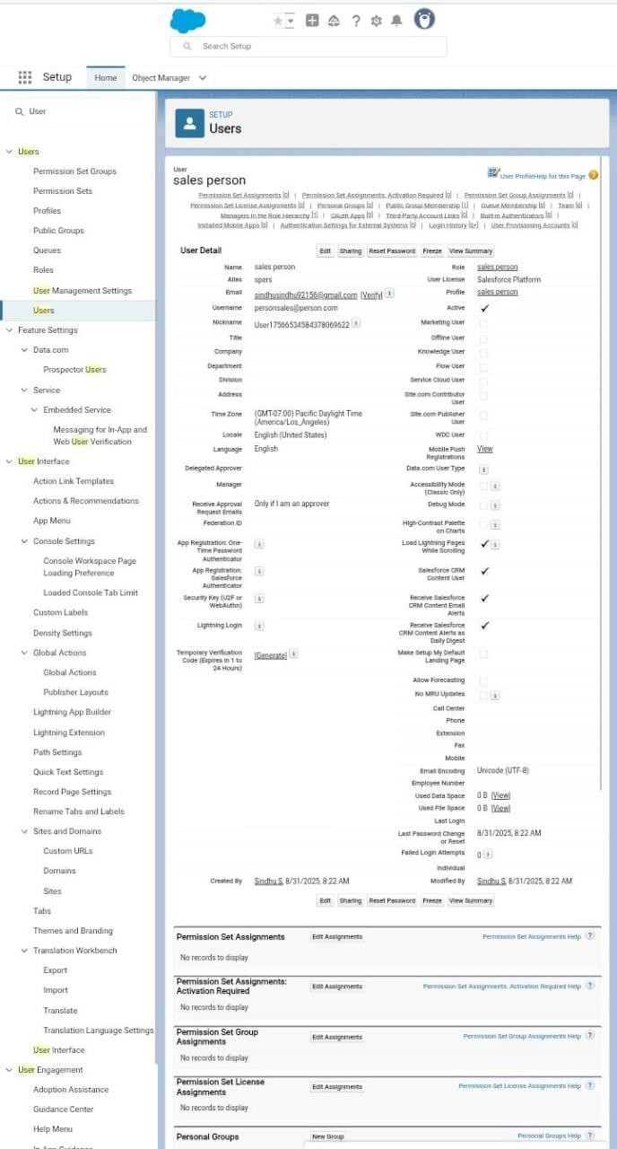

**Role and Role Hierarchy:**

**Creating Manager Role:**

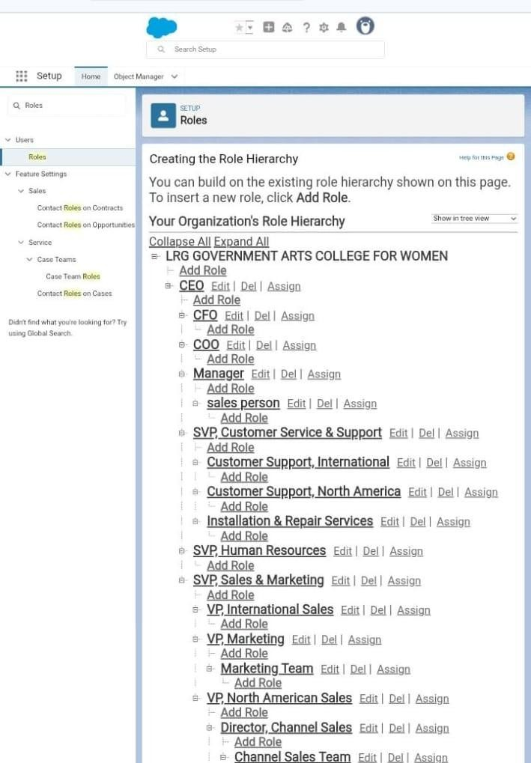

With the given information we also create another roles.

**Users:**

**Create Users:**

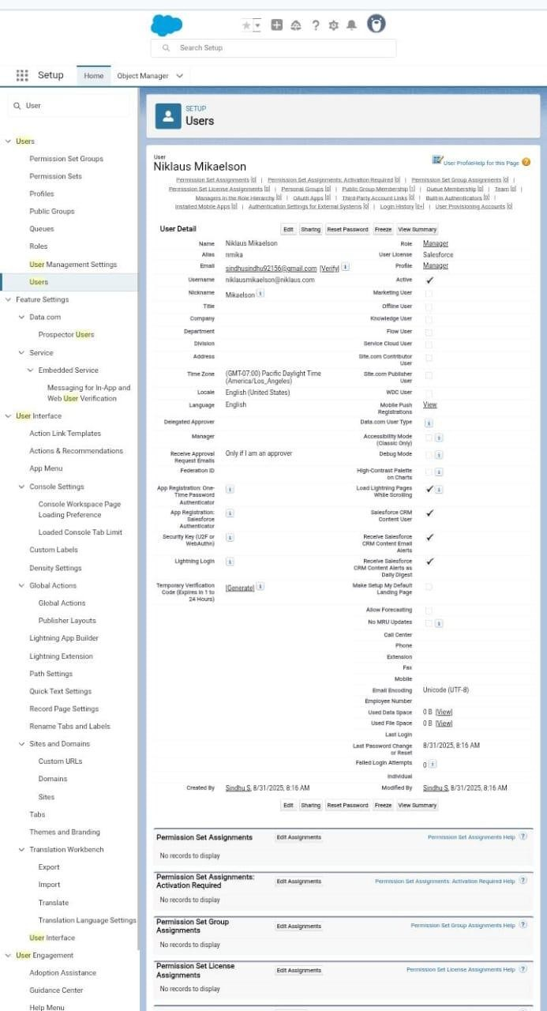

By repeating the same steps we create another users with the given instructions.

**Creating New Public Group:**

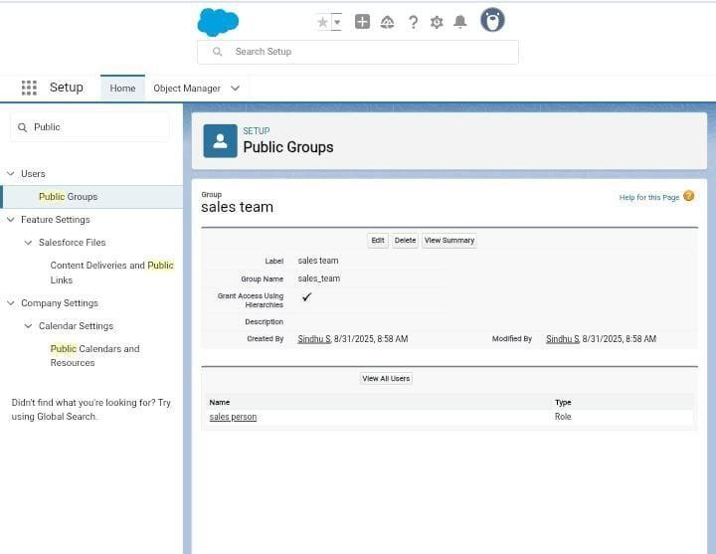

**Creating Sharing Setting:**

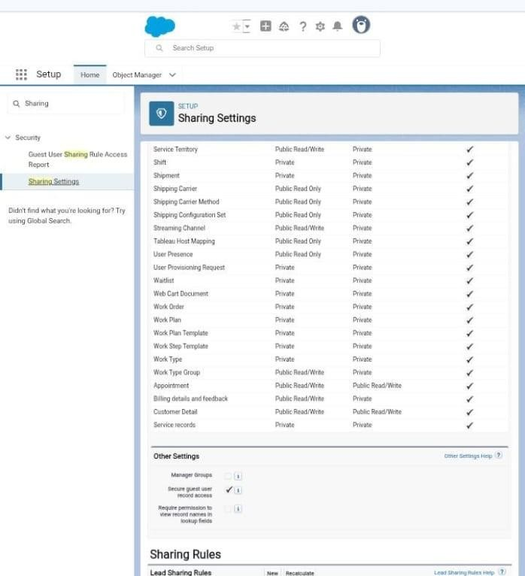

**Create a Flow:**

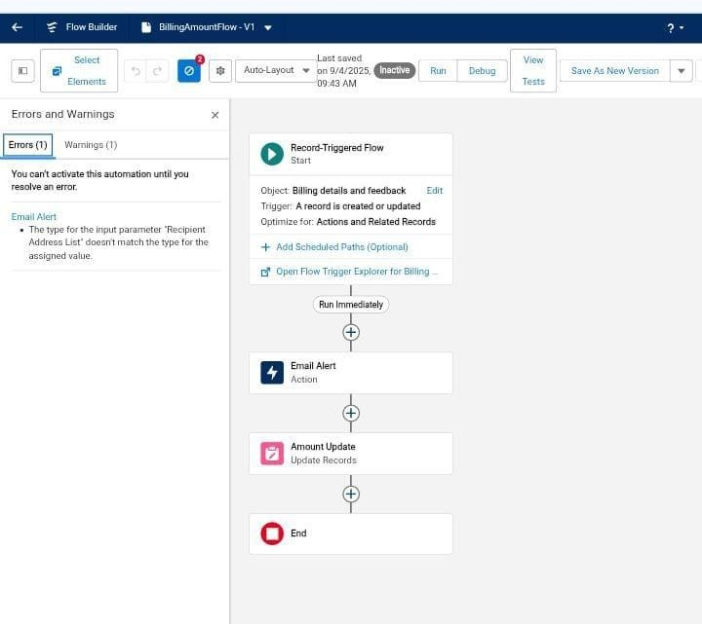

**Create Another Flow:**

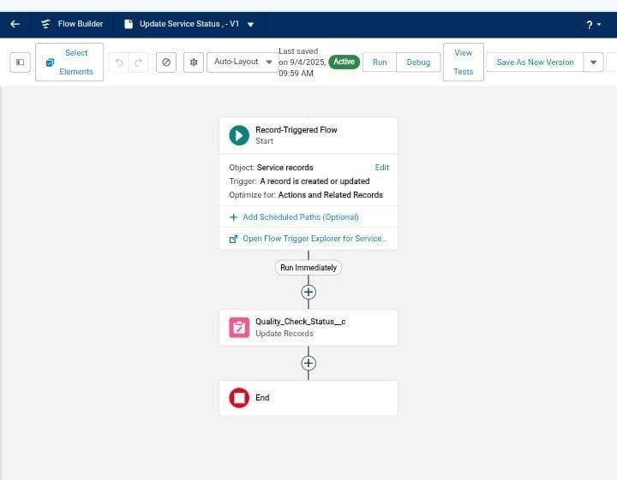

**Apex Handler:**

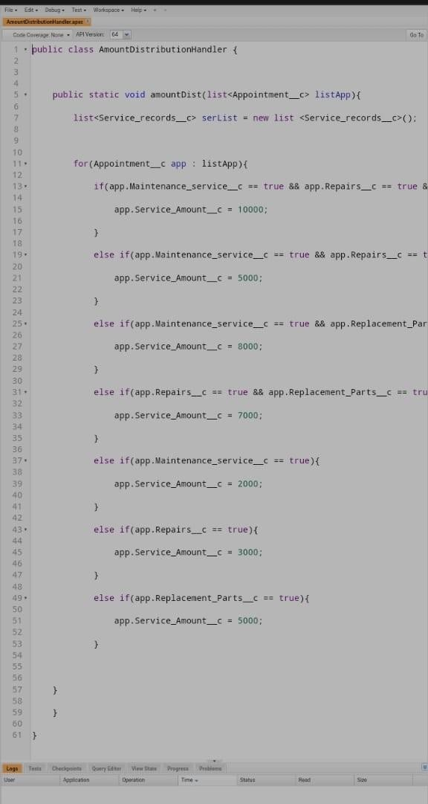

**Creating a Report:**

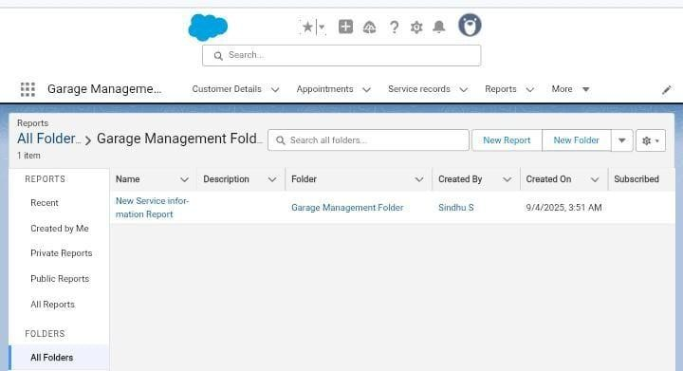

**Sharing a Report:**

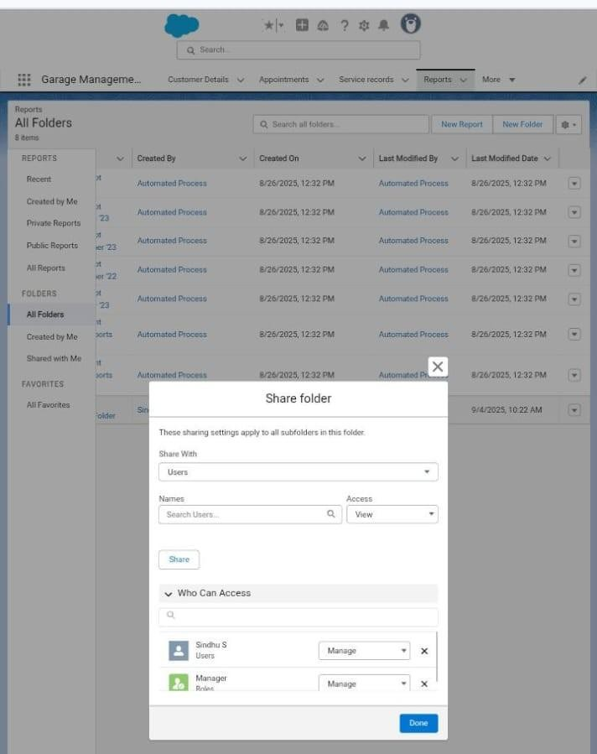

**Create a Dashboard :**

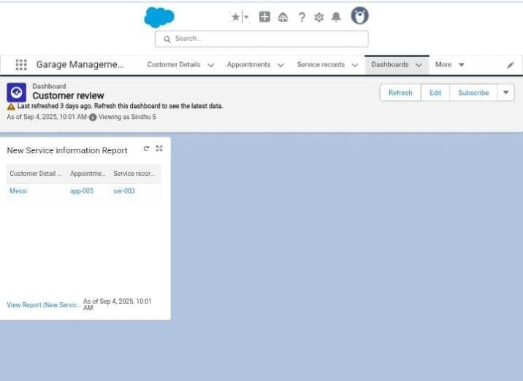

The user need to create the customer details name , appointment , service record for the record to show in dashboard. So now the customers schedule will be shown in dashboard .

